

Authors:

Ashraf Al Rashedy,

Document generated: 28th Sep 2017



Table of Contents

MSD E10 process model 3

General Ledger 5

New GL Account 6

GL Journal Entries 8

GL Budget 11

GL Period End 14

Financial Reporting 21

Accounts Receivable 24

Create/Update Customer Record 25

AR Invoice 28

Credit Note 31

Balance Transfer 34

AR Invoice Matching Correction 36

AR Payment 38

Matching Credit Memo/Invoice 41

AR Reporting 43

Accounts Payable 45

Create/Update Supplier Record 46

AP Invoice 49

Debit Memo 51

AP Payment 54

Matching Debit Memo/Invoice 57

LC 59

AP Reporting 62

Cash Management 64

Petty Cash Receipt 65

Petty Cash Issuance 67

Bank Reconciliation 69

Asset Management 72

Asset Maintenance 73

AM Period End 77

Projects 79

Projects 80

Integration 84

General Notes 85

# **MSD Finance Team Reviews on 10.10.2017**

# MSD E10 process model

|  |  |
| --- | --- |
|  | Version:  Version 1.0  Date:28th Sept 2017 |
|  |  |
|  |  |

The objective of this document is to have an overview of Epicor business processes with consideration towards MSD processes, the Epicor ERP modules to be implemented and any gaps highlighted on high level that may arise.

This section details the aims and objectives of the document. This document is not intended to be an in depth review of the business but to identify the business logic understanding of what the business is, who/how/where/when etc.

This review is the result of 5 day of interview with the staff of MSD and as such, is the consultant’s interpretation of the facts as heard. It does not intend to present every process in detail, only to determine whether the writer has a basic understanding of the Company.

This document is considered a ‘living’ document throughout the project implementation and will be updated as and when necessary. For example, if the initial agreed version suggest a one phase project implementation and has been written and approved on that basis and subsequently the project is to be split into two or more phases, then this document should be updated and re-issued for review and approval.

The following item(s) are included as they have been touched upon during the workshop:

General Ledger

Accounts Receivable

Accounts Payable

Cash Management

Asset Management

* Projects

Reporting Requirements related to the above modules

* Epicor 10 Standard Reports currently available
* Report requirements associated with SSRS/ Crystal reports configurations during implementation.

Abbreviations used:

BPM – Business Process Management configuration (technical configuration using available tools)

Enhancement – Customization to provide additional functionality not available in system

Configuration – setup of specific data, or usage of existing functionality to achieve result

Custom fields – addition of User Defined fields to an existing object

Integration – integrating third party software with Epicor 10 application.

Dashboard – a custom screen that allows to view existing data in a specific way as well as make calculations with this data.

General Ledger

The following item(s) are in this Group:

* New GL Account
* GL Journal Entries
* GL Budget
* GL Period End
* Financial Reporting

|  |
| --- |
| User Notes |
| Process Group definition:  This group contains the process related to definition and creation of GL account  GL Budget records in Epicor 10 database which are used to create general ledger  Journals and financial reporting. |

New GL Account

|  |
| --- |
| User Notes |
| Process definition:  This process starts with the request to create a new GL account which will be used as a base for the journals.  This workflow starts from receiving a request outside the system to create new GL account, A user will check if this account already exist or not, if not he will create it on Epicor10 then notify the requester outside the system. |

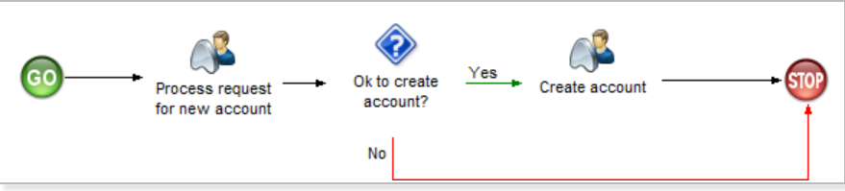

1. Process: New GL Account

Process Content

* Create account

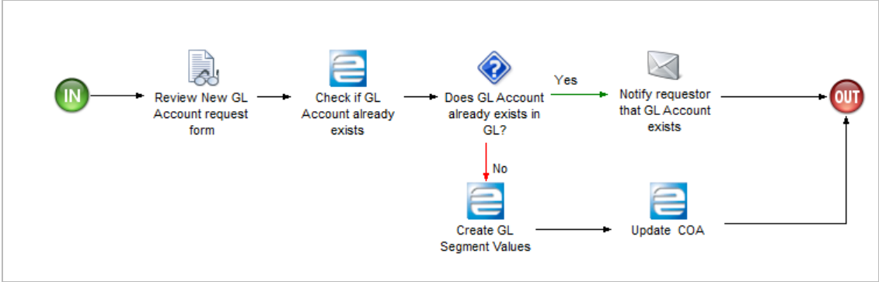

2. Process: New GL Account, Stage: Create account

* Process request for new account

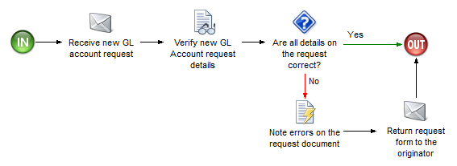

3. Process: New GL Account, Stage: Process request for new account

**GAPs/ Configuration changes Identified:**

|  |  |  |  |
| --- | --- | --- | --- |
| Definition | Type |  | Comments |
| N/A | N/A |  | N/A |

GL Journal Entries

|  |
| --- |
| User Notes |
| Process definition:  This process starts with the creation of manual journal entries which is not related to any sub ledger for example : Amortization of capital grants and expense allocation.  This workflow starts from creating GL group, Creating journal entry then post the entries. |

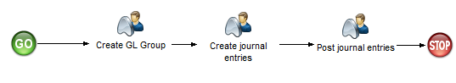

4. Process: GL Journal Entries

Process Content

* Create GL Group

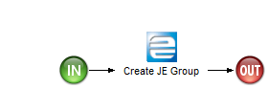

5. Process: GL Journal Entries, Stage: Create GL Group

* Create journal entries

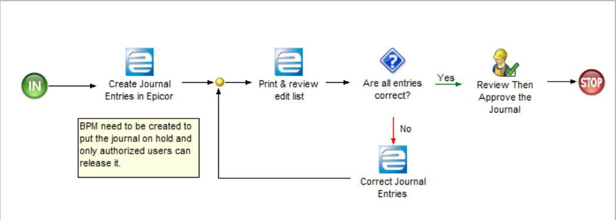

6. Process: GL Journal Entries, Stage: Create journal entries

**GAPs/ Configuration changes Identified:**

|  |  |  |  |
| --- | --- | --- | --- |
| Definition | Type |  | Comments |
| Put the journal on hold | BPM |  | The journal should be put on hold once it is created by the user and only authorized person can un-Hold it. |
| Put the signatures on printed edit list | Enhancement |  | Put the name(s) and signature space for the user(s) who need to sign on the edit list. |

* Post journal entries

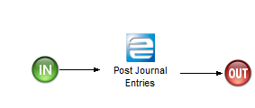

7. Process: GL Journal Entries, Stage: Post journal entries

MSD Comments:

There should be a restrictions for Manual Journals to GL accounts. There should be stages for approving the manual journals

GL Budget

|  |
| --- |
| User Notes |
| Process definition:  This process starts with internal budget preparation by MSD outside the system and after it is approved it will be uploaded on Epicor10 then validation is required for each procurement category at requisition , Purchase order and miscellaneous invoice level.  This workflow starts from budget preparation, Process budget and execute budget. |

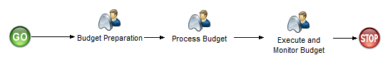

8. Process: GL Budget

Process Content

* Budget Preparation

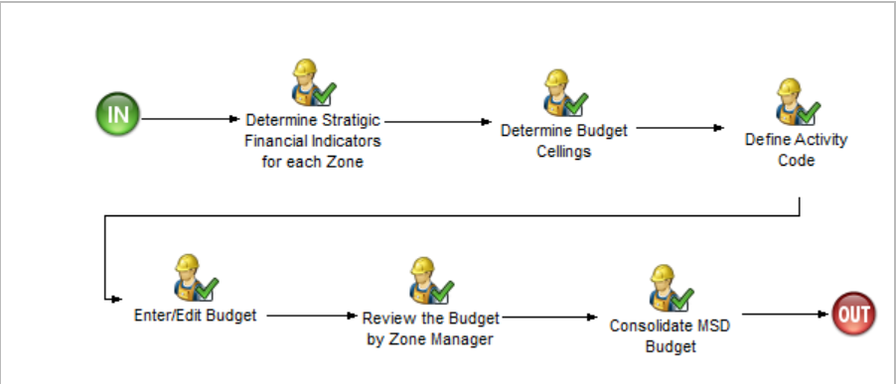

9. Process: GL Budget, Stage: Budget Preparation

**MSD Review Comments**

* MSD budget is activity based budgeting
* Correction on (9) review the budget by zonal manager – Review the Budget by Manager
* Restriction is not recommended on requisitions, however there should be the way the budget balance can be printed before raising a requisition for a particular activity
* Direct expenses, miscellaneous, staff payments validation should be done using the activity codes budget
* We need to have activity code budget tracker in order to obtain the budget balance of a particular activity
* We need clarity on budget control on requisitions
* No need of restrictions for the approved purchase orders
* Process Budget

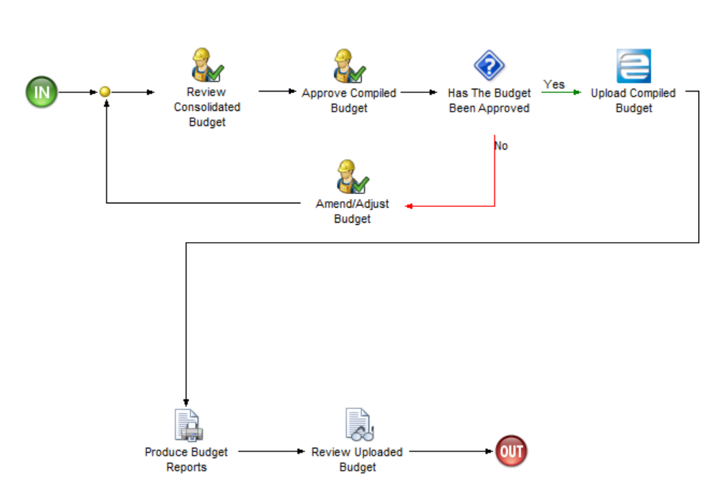

10. Process: GL Budget, Stage: Process Budget

* Execute and Monitor Budget

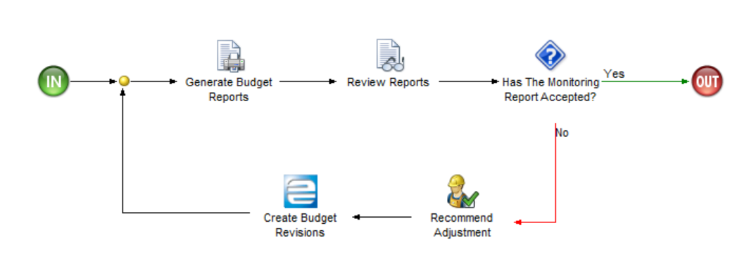

11. Process: GL Budget, Stage: Execute and Monitor Budget

**GAPs/ Configuration changes Identified:**

|  |  |  |  |
| --- | --- | --- | --- |
| Definition | Type |  | Comments |
| Budget control for each procurement category | Enhancement |  | Budget control for requisition and miscellaneous invoice level |

GL Period End

|  |
| --- |
| User Notes |
| Process definition:  This process starts with verifying all unposted entries for all sub ledgers then compare the balances against GL balance before closing the GL period.  This workflow starts from verify the entries of accounts receivable, Accounts payable, inventory, Cash management and asset management by using the reconciliation reports. |

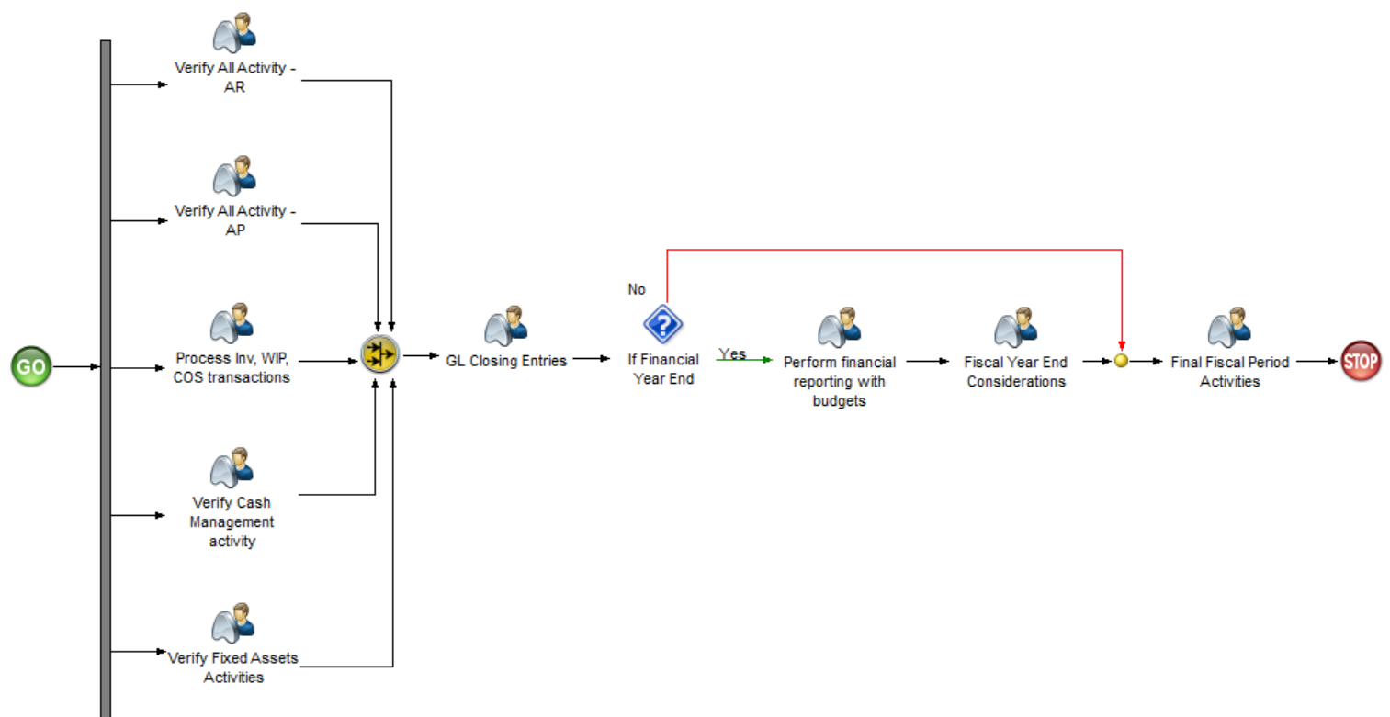

12. Process: GL Period End

Process Content

* Verify All Activity - AR

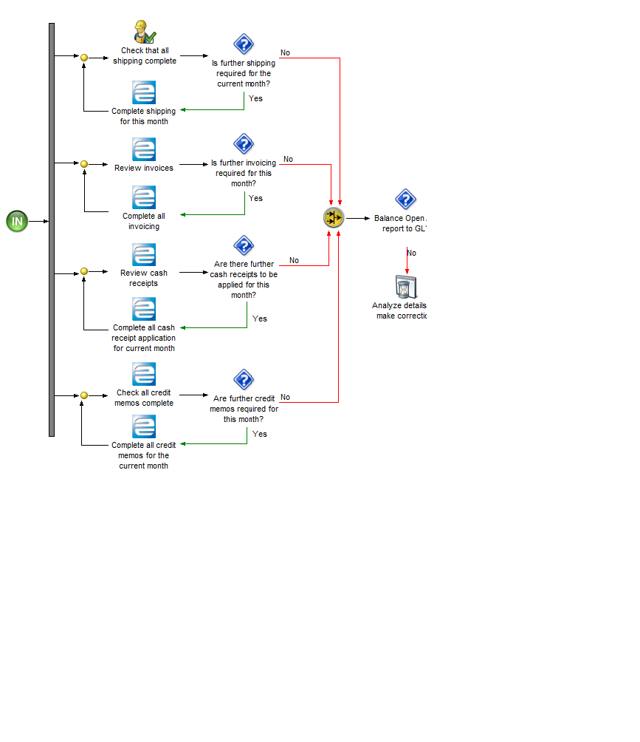

13. Process: GL Period End, Stage: Verify All Activity - AR

* Verify All Activity - AP

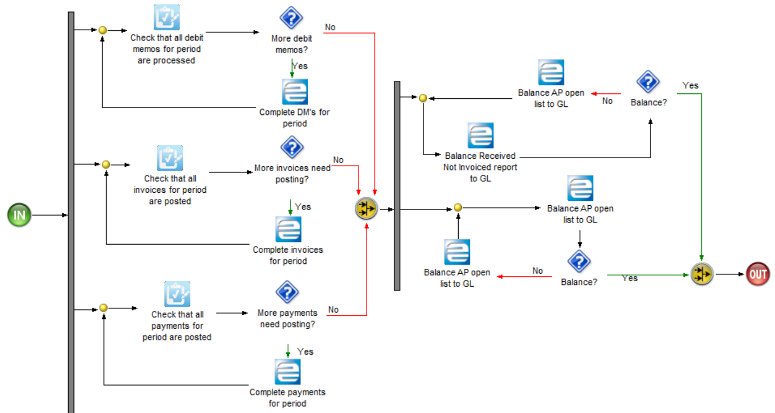

14. Process: GL Period End, Stage: Verify All Activity - AP

* Process Inv, WIP, COS transactions

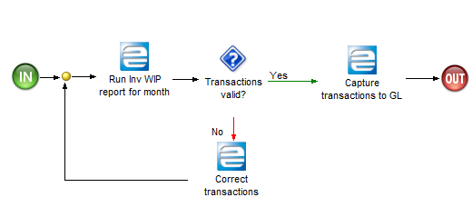

15. Process: GL Period End, Stage: Process Inv, WIP, COS transactions

* Verify Cash Management activity

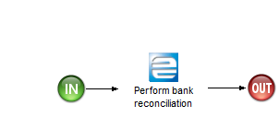

16. Process: GL Period End, Stage: Verify Cash Management activity

- The should automation for processing WIP transactions to GL

- There should be a similar transactions details for WIP and GL

- GL transactions should be detailed

* GL Closing Entries

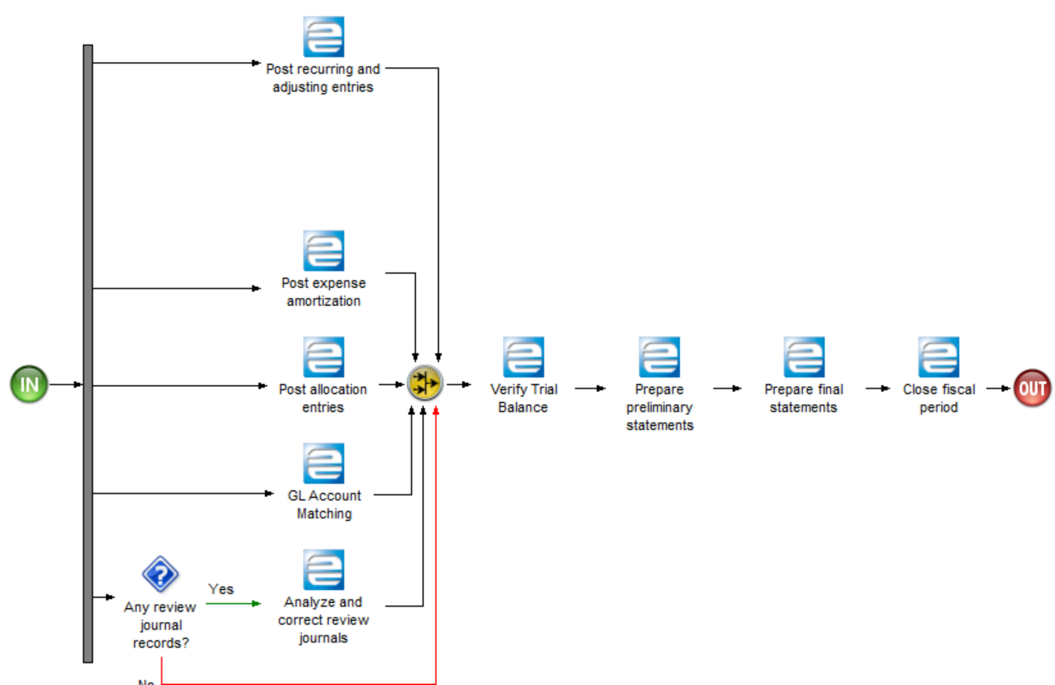

17. Process: GL Period End, Stage: GL Closing Entries

* Fiscal Year End Considerations

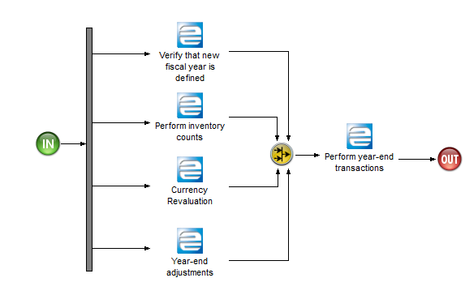

18. Process: GL Period End, Stage: Fiscal Year End Considerations

* Final Fiscal Period Activities

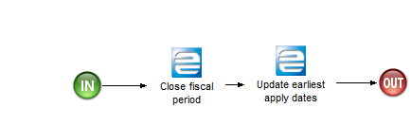

19. Process: GL Period End, Stage: Final Fiscal Period Activities

* Perform financial reporting with budgets

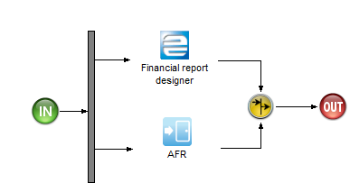

20. Process: GL Period End, Stage: Perform financial reporting with budgets

* Verify Fixed Assets Activities

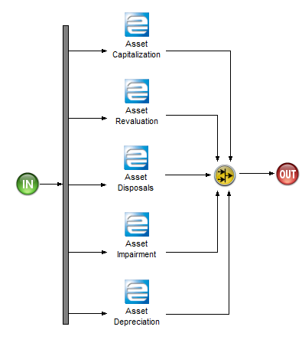

21. Process: GL Period End, Stage: Verify Fixed Assets Activities

**GAPs/ Configuration changes Identified:**

|  |  |  |  |
| --- | --- | --- | --- |
| Definition | Type |  | Comments |
| N/A | N/A |  | N/A |

MSD Comments

* The fixed asset activities should come before year end closure.

Note: 1. Financial statements report are not included in this document for Epicor10.

* The financial statements report is mandatory and will include:
  + Statement of financial performance
  + Statement of financial position
  + Statement of cash flow

2. The payroll activities are not included in this document for Epicor10.

- The payroll activities are important for finance operations, therefore they need to be reworked. With reference to the training held for upgrade MSD recommended for Epicor10 payroll module.

Financial Reporting

|  |
| --- |
| User Notes |
| Process definition:  This process starts with reviewing the financial reports using the standard reports available on Epicor10 or using customized reports by advanced financial reporting(AFR) tool.  This workflow starts from choosing the reporting tool to review the financial reports like balance sheet, Income statement, Site report and cash flow analysis. |

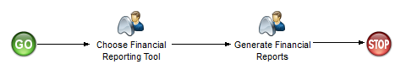

22. Process: Financial Reporting

Process Content

* Choose Financial Reporting Tool

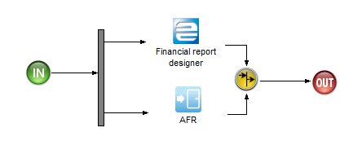

23. Process: Financial Reporting, Stage: Choose Financial Reporting Tool

* Generate Financial Reports

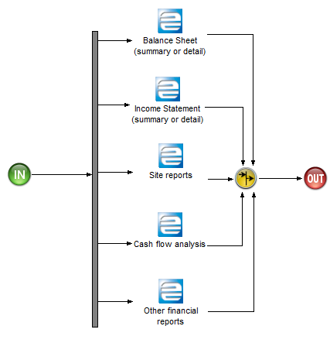

24. Process: Financial Reporting, Stage: Generate Financial Reports

**GAPs/ Configuration changes Identified:**

|  |  |  |  |
| --- | --- | --- | --- |
| Definition | Type |  | Comments |
| N/A | N/A |  | N/A |

Accounts Receivable

The following item(s) are in this Group:

* Create/Update Customer Record
* AR Invoice
* Credit Note
* Balance Transfer
* AR Invoice Matching Correction
* AR Payment
* Matching Credit Memo/Invoice
* AR Reporting

|  |
| --- |
| User Notes |
| Process definition:  This group contains the process related to create accounts receivable invoice , payment, Credit memo records in Epicor10 database then generate reports that shows the balances that used in the AR reconciliation with general ledger. |

Create/Update Customer Record

|  |
| --- |
| User Notes |
| Process definition:  This process starts with creating or updating the customer record in Epicor10 database.  This workflow starts from receiving request outside the system for creating or updating the customer record in Epicor10 database. |

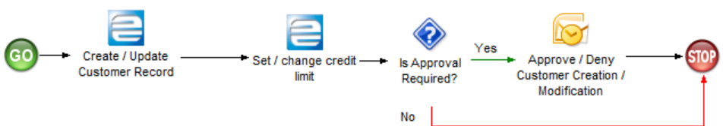

25. Process: Create/Update Customer Record

Process Content

* Create / Update Customer Record

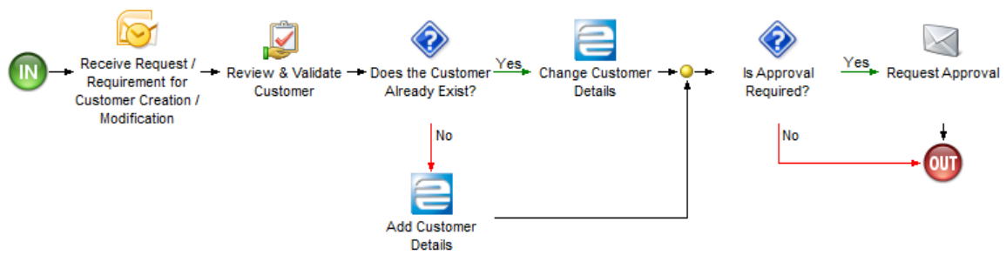

26. Process: Create/Update Customer Record, Stage: Create / Update Customer Record

* Set / change credit limit

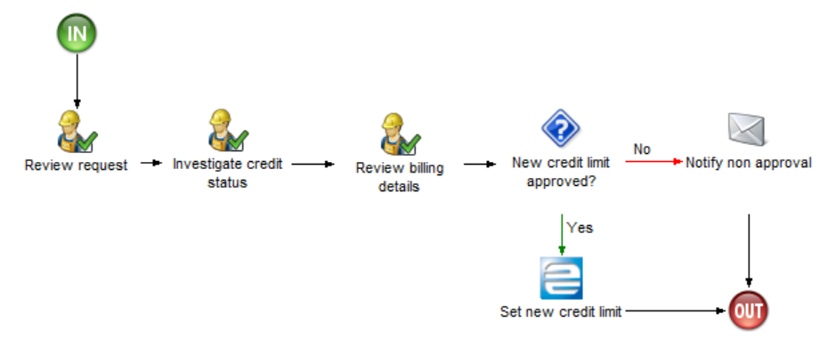

27. Process: Create/Update Customer Record, Stage: Set / change credit limit

* Approve / Deny Customer Creation / Modification

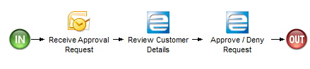

28. Process: Create/Update Customer Record, Stage: Approve / Deny Customer Creation / Modification

**GAPs/ Configuration changes Identified:**

|  |  |  |  |
| --- | --- | --- | --- |
| Definition | Type |  | Comments |
| N/A | N/A |  | N/A |

AR Invoice

|  |
| --- |
| User Notes |
| Process definition:  This process starts with generate sales invoice from the system based on shipment or miscellaneous invoice .  This workflow starts from creating AR invoice group ,generate the invoice then post. |

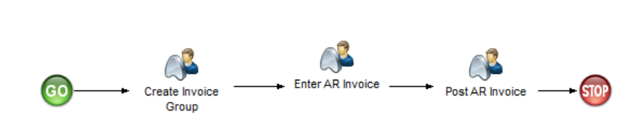

29. Process: AR Invoice

Process Content

* Create Invoice Group

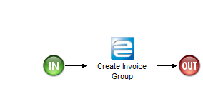

30. Process: AR Invoice, Stage: Create Invoice Group

* Post AR Invoice

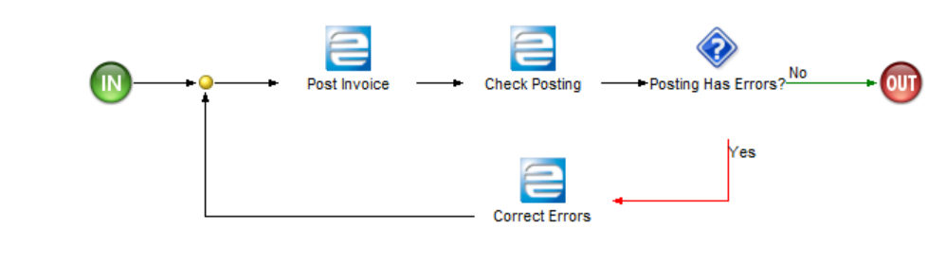

31. Process: AR Invoice, Stage: Post AR Invoice

* Enter AR Invoice

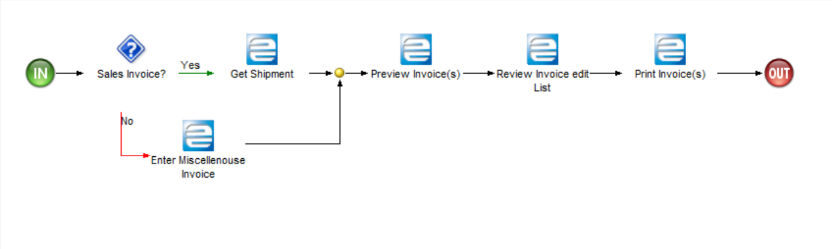

32. Process: AR Invoice, Stage: Enter AR Invoice

**GAPs/ Configuration changes Identified:**

|  |  |  |  |
| --- | --- | --- | --- |
| Definition | Type |  | Comments |
| N/A | N/A |  | N/A |

Credit Note

|  |
| --- |
| User Notes |
| Process definition:  This process starts with creating credit note for customer’s goods return through return material authorization cycle and creating a credit memo to reduce the customer balance.  This workflow starts from creating credit memo group ,generate/Create credit memo then post. |

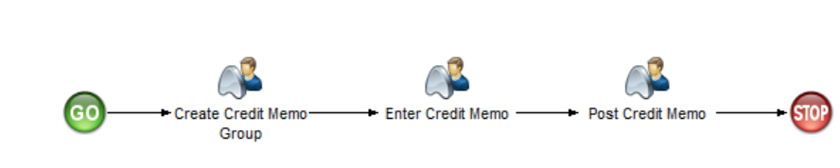

33. Process: Credit Note

Process Content

* Create Credit Memo Group

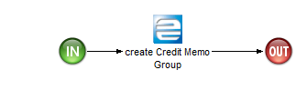

34. Process: Credit Note, Stage: Create Credit Memo Group

* Enter Credit Memo

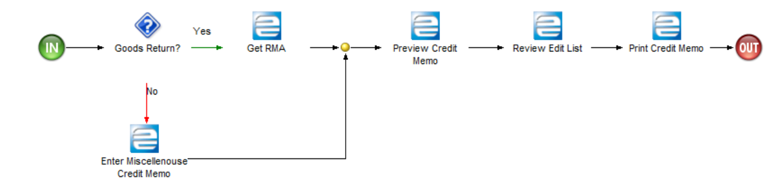

35. Process: Credit Note, Stage: Enter Credit Memo

* Post Credit Memo

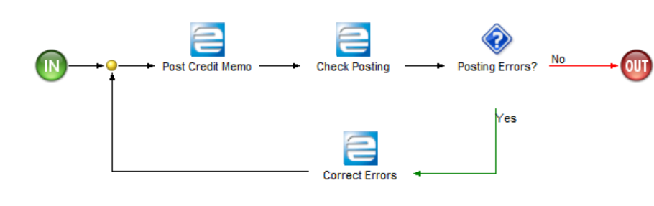

36. Process: Credit Note, Stage: Post Credit Memo

**GAPs/ Configuration changes Identified:**

|  |  |  |  |
| --- | --- | --- | --- |
| Definition | Type |  | Comments |
| N/A | N/A |  | N/A |

Balance Transfer

|  |
| --- |
| User Notes |
| Process definition:  This process starts with creating credit or debit memo to transfer balances between customer accounts.  This workflow starts from creating credit memo or debit memo to appropriate customer accounts. |

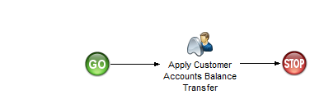

37. Process: Balance Transfer

Process Content

* Apply Customer Accounts Balance Transfer

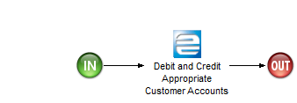

38. Process: Balance Transfer, Stage: Apply Customer Accounts Balance Transfer

**GAPs/ Configuration changes Identified:**

|  |  |  |  |
| --- | --- | --- | --- |
| Definition | Type |  | Comments |
| N/A | N/A |  | N/A |

AR Invoice Matching Correction

|  |
| --- |
| User Notes |
| Process definition:  This process starts with rematch the matched invoice for correction.  This workflow starts from rematch already matched invoices. |

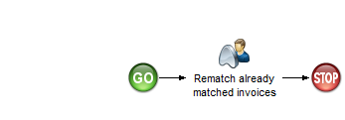

39. Process: AR Invoice Matching Correction

Process Content

* Rematch already matched invoices

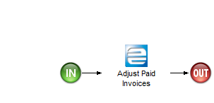

40. Process: AR Invoice Matching Correction, Stage: Rematch already matched invoices

**GAPs/ Configuration changes Identified:**

|  |  |  |  |
| --- | --- | --- | --- |
| Definition | Type |  | Comments |
| N/A | N/A |  | N/A |

AR Payment

|  |
| --- |
| User Notes |
| Process definition:  This process starts with AR payment, Payment can be against invoice or deposit payment.  This workflow starts from creating payment group, enter payment then post the payment. |

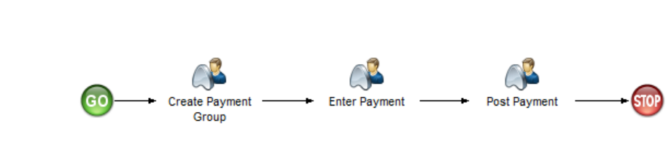

41. Process: AR Payment

Process Content

* Create Payment Group

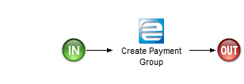

42. Process: AR Payment, Stage: Create Payment Group

* Enter Payment

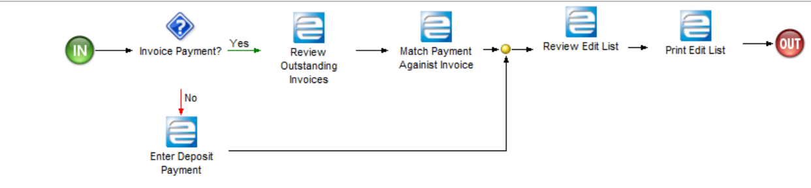

43. Process: AR Payment, Stage: Enter Payment

* Post Payment

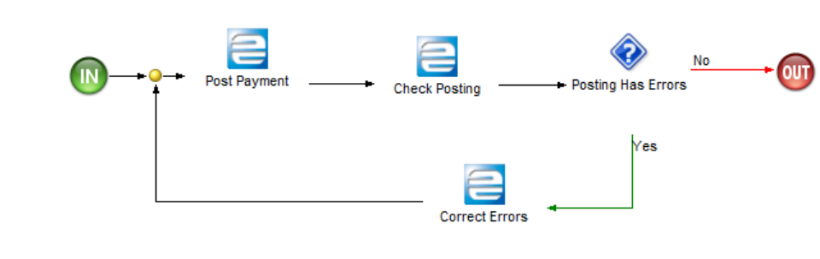

44. Process: AR Payment, Stage: Post Payment

**GAPs/ Configuration changes Identified:**

|  |  |  |  |
| --- | --- | --- | --- |
| Definition | Type |  | Comments |
| N/A | N/A |  | N/A |

Matching Credit Memo/Invoice

|  |
| --- |
| User Notes |
| Process definition:  This process starts with matching the prepayment or credit memo against invoice.  This workflow starts from selecting the prepayment or credit memo and matching against the invoice. |

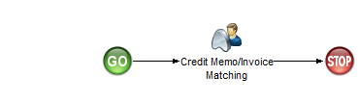

45. Process: Matching Credit Memo/Invoice

Process Content

* Credit Memo/Invoice Matching

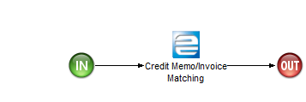

46. Process: Matching Credit Memo/Invoice, Stage: Credit Memo/Invoice Matching

**GAPs/ Configuration changes Identified:**

|  |  |  |  |
| --- | --- | --- | --- |
| Definition | Type |  | Comments |
| N/A | N/A |  | N/A |

AR Reporting

|  |
| --- |
| User Notes |
| Process definition:  This process starts with generating the AR reconciliation reports to be compared with the general ledger balances.  This workflow starts from generating the AR reports. |

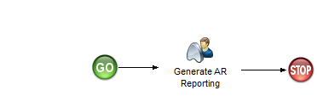

47. Process: AR Reporting

Process Content

* Generate AR Reporting

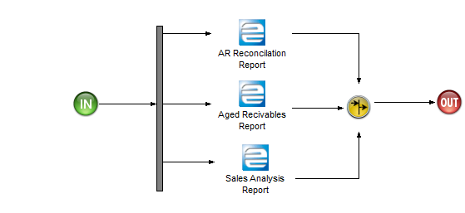

48. Process: AR Reporting, Stage: Generate AR Reporting

**GAPs/ Configuration changes Identified:**

|  |  |  |  |
| --- | --- | --- | --- |
| Definition | Type |  | Comments |
| N/A | N/A |  | N/A |

MSD REVIEW COMMENTS:

New Report in E10 and was customized in E9.

* Kindly include the summary of customer accounts. This is report includes opening balance, total debits, total credits and closing balances of individual customers.

Accounts Payable

The following item(s) are in this Group:

* Create/Update Supplier Record
* AP Invoice
* Debit Memo
* AP Payment
* Matching Debit Memo/Invoice
* LC

|  |
| --- |
| User Notes |
| Process definition:  This group contains the process related to create accounts payable invoice , payment, debit memo records in Epicor10 database |

Create/Update Supplier Record

|  |
| --- |
| User Notes |
| Process definition:  This process starts with creating or updating supplier record in Epicor10 database.  This workflow starts from receiving request outside the system for creating or updating supplier record in Epicor10 database. |

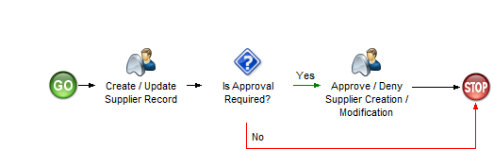

49. Process: Create/Update Supplier Record

Process Content

* Create / Update Supplier Record

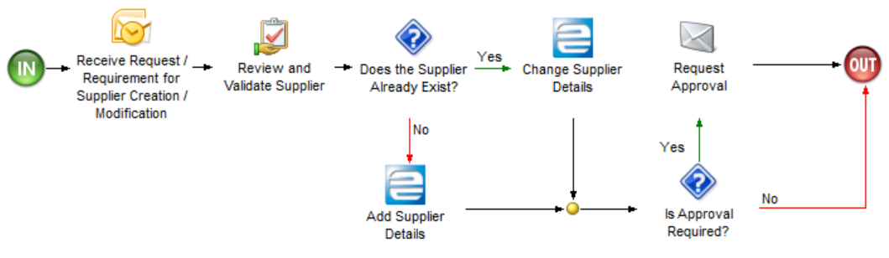

50. Process: Create/Update Supplier Record, Stage: Create / Update Supplier Record

* Approve / Deny Supplier Creation / Modification

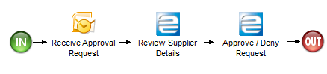

51. Process: Create/Update Supplier Record, Stage: Approve / Deny Supplier Creation / Modification

**GAPs/ Configuration changes Identified:**

|  |  |  |  |
| --- | --- | --- | --- |
| Definition | Type |  | Comments |
| N/A | N/A |  | N/A |

AP Invoice

|  |
| --- |
| User Notes |
| Process definition:  This process starts with enter supplier invoice based on goods received notes or miscellaneous invoice for service.  This workflow starts from creating AP invoice group ,Enter the invoice then post. |

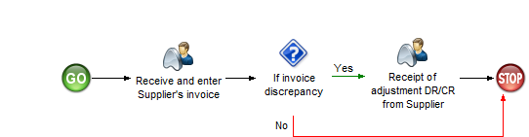

52. Process: AP Invoice

Process Content

* Receipt of adjustment DR/CR from Supplier

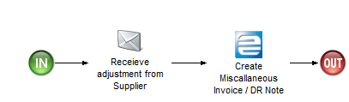

53. Process: AP Invoice, Stage: Receipt of adjustment DR/CR from Supplier

* Receive and enter Supplier's invoice

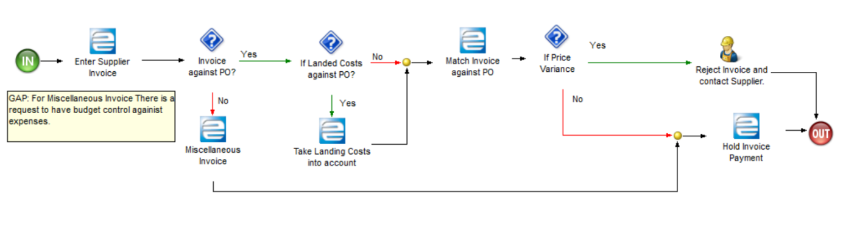

54. Process: AP Invoice, Stage: Receive and enter Supplier's invoice

**GAPs/ Configuration changes Identified:**

|  |  |  |  |
| --- | --- | --- | --- |
| Definition | Type |  | Comments |
| Valid the expense against budget | BPM |  | In Miscellaneous invoice: Create a BPM to stop the user if the expense exceeds the budget, notification should be sent for the user who can control the budget |

Debit Memo

|  |
| --- |
| User Notes |
| Process definition:  This process starts with creating debit note for supplier’s goods return through discrepant material return cycle and creating a debit memo to reduce the supplier balance.  This workflow starts from creating debit memo group ,generate/Create debit memo then post. |

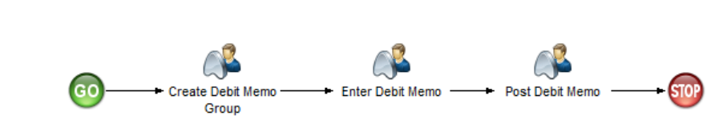

55. Process: Debit Memo

Process Content

* Create Debit Memo Group



56. Process: Debit Memo, Stage: Create Debit Memo Group

* Enter Debit Memo

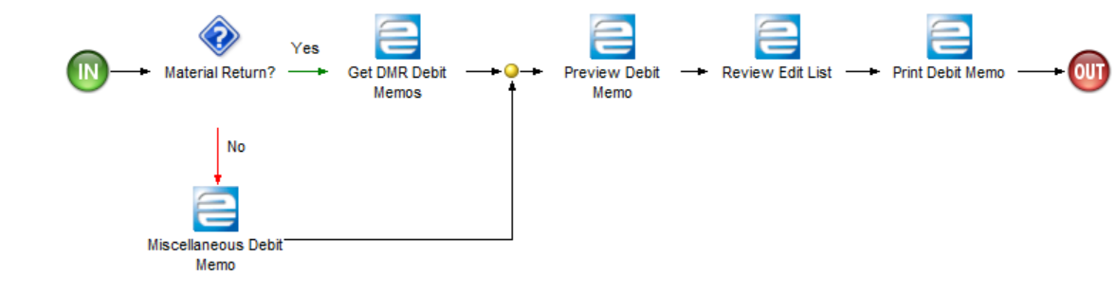

57. Process: Debit Memo, Stage: Enter Debit Memo

* Post Debit Memo

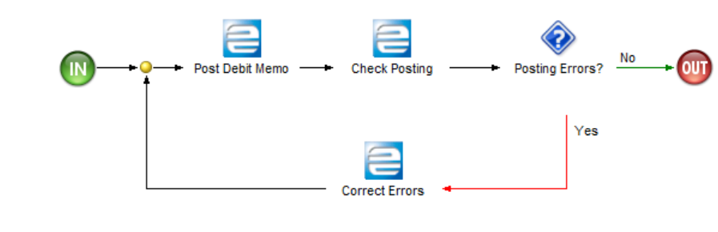

58. Process: Debit Memo, Stage: Post Debit Memo

**GAPs/ Configuration changes Identified:**

|  |  |  |  |
| --- | --- | --- | --- |
| Definition | Type |  | Comments |
| N/A | N/A |  | N/A |

AP Payment

|  |
| --- |
| User Notes |
| Process definition:  This process starts with AP payment, Payment can be against invoice or prepayment.  This workflow starts from creating payment group, enter payment then post the payment. |

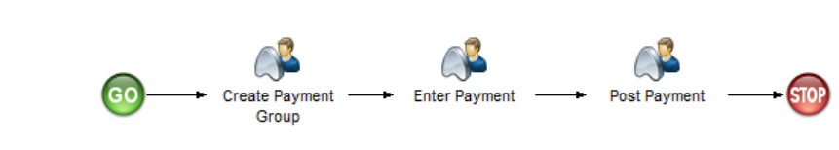

59. Process: AP Payment

Process Content

* Create Payment Group

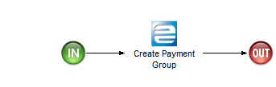

60. Process: AP Payment, Stage: Create Payment Group

* Enter Payment

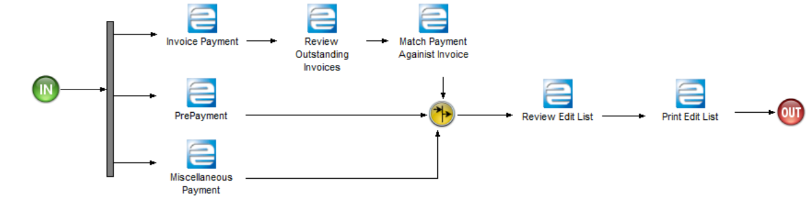

61. Process: AP Payment, Stage: Enter Payment

**MSD Comments.**

* There is a challenge on payment voucher with multiple GL lines. The GL transactions are well processed but during printing for approval few lines appeared in the hard copy. We need in E10 all the lines to be printed.
* There is challenge on GL report balances differs from the detailed GL and GL summary balances

* Post Payment

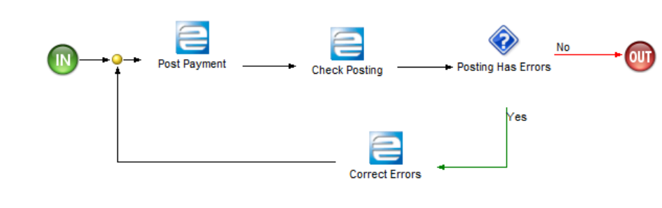

62. Process: AP Payment, Stage: Post Payment

**GAPs/ Configuration changes Identified:**

|  |  |  |  |
| --- | --- | --- | --- |
| Definition | Type |  | Comments |
| N/A | N/A |  | N/A |

Matching Debit Memo/Invoice

|  |
| --- |
| User Notes |
| Process definition:  This process starts with matching the prepayment or debit memo against invoice.  This workflow starts from selecting the prepayment or debit memo and matching against the invoice. |

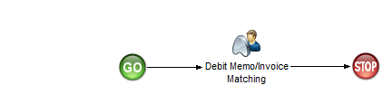

63. Process: Matching Debit Memo/Invoice

Process Content

* Debit Memo/Invoice Matching

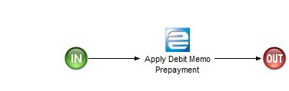

64. Process: Matching Debit Memo/Invoice, Stage: Debit Memo/Invoice Matching

**GAPs/ Configuration changes Identified:**

|  |  |  |  |
| --- | --- | --- | --- |
| Definition | Type |  | Comments |
| N/A | N/A |  | N/A |

**MSD Review Comments**:

* There is a challenged to correct wrongly matched invoices. That is there is no possibility in E9 to reinstate the matched invoices incase there was an mistake during matching of the invoices

LC

|  |
| --- |
| User Notes |
| Process definition:  This process starts with open LC for import goods , make advanced payment against LC and link purchase order with LC.  This workflow starts from open LC, Process LC and close LC. |

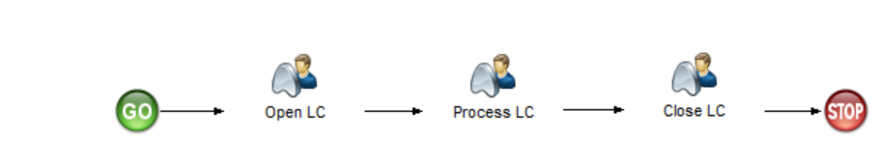

65. Process: LC

Process Content

* Open LC

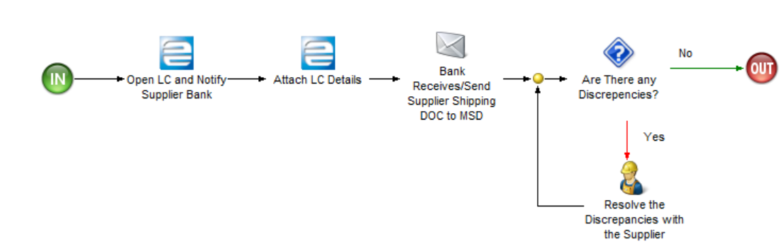

66. Process: LC, Stage: Open LC

* Process LC

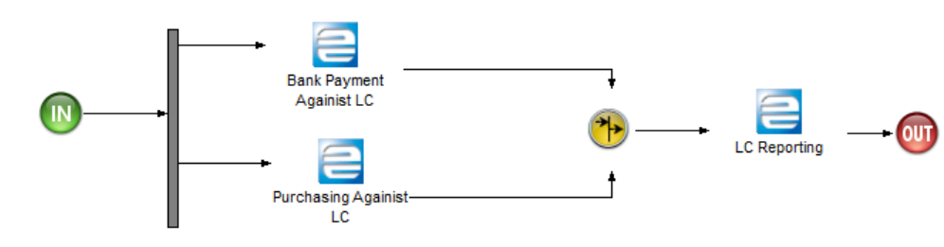

67. Process: LC, Stage: Process LC

* Close LC

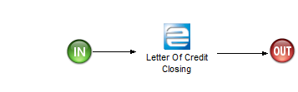

68. Process: LC, Stage: Close LC

**GAPs/ Configuration changes Identified:**

|  |  |  |  |
| --- | --- | --- | --- |
| Definition | Type |  | Comments |
| N/A | N/A |  | N/A |

AP Reporting

|  |
| --- |
| User Notes |
| Process definition:  This process starts with generating the AP reconciliation reports to be compared with the general ledger balances.  This workflow starts from generating the AP reports. |



69. Process: AP Reporting

Process Content

* Generate AP Reporting

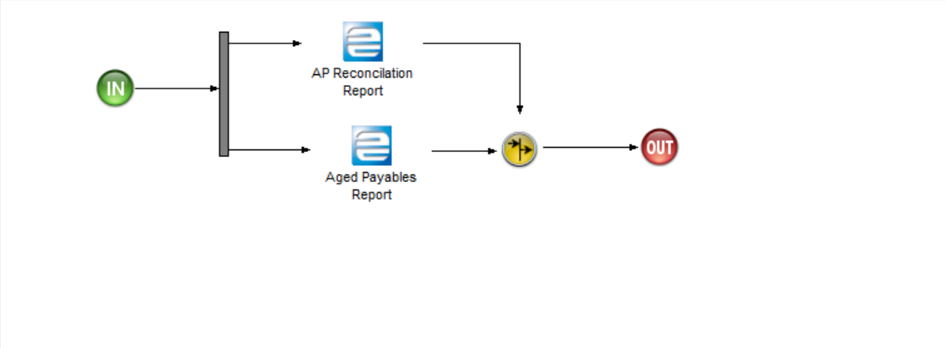

70. Process: AP Reporting, Stage: Generate AP Reporting

**GAPs/ Configuration changes Identified:**

|  |  |  |  |
| --- | --- | --- | --- |
| Definition | Type |  | Comments |
| AP Reconciliation report | Dashboard |  | Create AP reconciliation report similar to standard AR reconciliation report. |

Cash Management

The following item(s) are in this Group:

* Petty Cash Receipt
* Petty Cash Issuance
* Bank Reconciliation

|  |
| --- |
| User Notes |
| Process definition:  This group contains the process related to creating cash issue and cash receipt records in Epicor10 database.  For each plant(site), There is a separate cash desk for receipt and issue to control the limit. |

Petty Cash Receipt

|  |
| --- |
| User Notes |
| Process definition:  This process starts with cash receipt for employee loan repayment, customer paying cash, cash desk replenishment from other location or bank and miscellaneous sources.  This workflow starts from create petty cash receipt. |

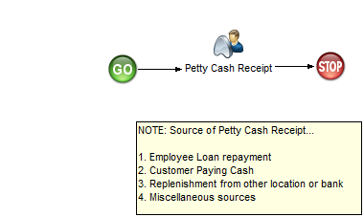

71. Process: Petty Cash Receipt

Process Content

* Petty Cash Receipt

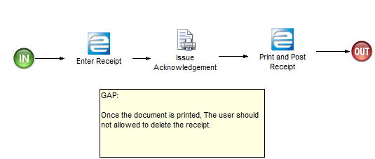

72. Process: Petty Cash Receipt, Stage: Petty Cash Receipt

**GAPs/ Configuration changes Identified:**

|  |  |  |  |
| --- | --- | --- | --- |
| Definition | Type |  | Comments |
| The user shouldn’t be allowed to delete the document after print | BPM |  | Create a BPM to prevent the user from deleting the petty cash document after print |

Petty Cash Issuance

|  |
| --- |
| User Notes |
| Process definition:  This process starts with cash issue for employee loan payment, paying cash to the supplier and any other miscellaneous source.  This workflow starts from create petty cash issue. |

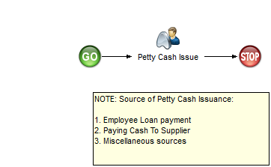

73. Process: Petty Cash Issuance

Process Content

* Petty Cash Issue

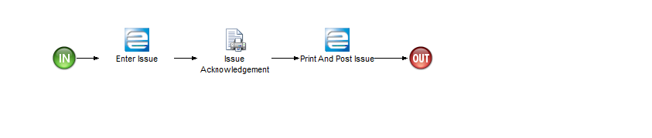

72. Process: Petty Cash Issuance, Stage: Petty Cash Issue

**GAPs/ Configuration changes Identified:**

|  |  |  |  |
| --- | --- | --- | --- |
| Definition | Type |  | Comments |
| The user shouldn’t be allowed to delete the document after print | BPM |  | Create a BPM to prevent the user from deleting the petty cash document after print |

Bank Reconciliation

|  |
| --- |
| User Notes |
| Process definition:  This process starts with process bank statement that received from the bank and compare it against the current transactions in Epicor10 and if there is something missing, the user need to enter it on the system to be matched with the statement.  This workflow starts from process bank statement. |

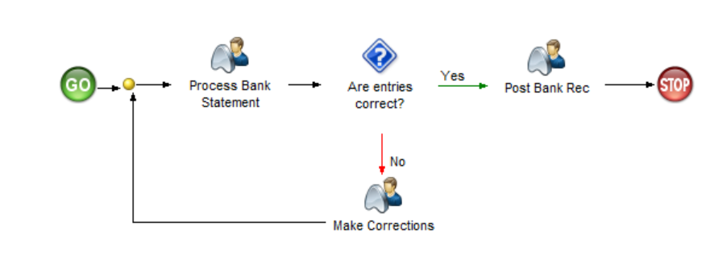

74. Process: Bank Reconciliation

Process Content

* Process Bank Statement

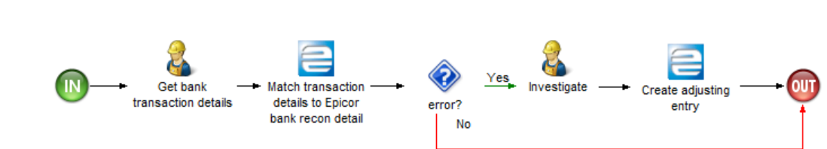

75. Process: Bank Reconciliation, Stage: Process Bank Statement

* Make Corrections

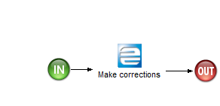

75. Process: Bank Reconciliation, Stage: Make Corrections

* Post Bank Rec

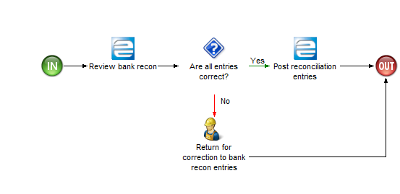

76. Process: Bank Reconciliation, Stage: Post Bank Rec

**GAPs/ Configuration changes Identified:**

|  |  |  |  |
| --- | --- | --- | --- |
| Definition | Type |  | Comments |
| N/A | N/A |  | N/A |

Asset Management

The following item(s) are in this Group:

* Asset Maintenance
* AM Period End

|  |
| --- |
| User Notes |
| Process definition:  This group contains the process related to asset transactions and asset period end in Epicor10 database. |

Asset Maintenance

|  |
| --- |
| User Notes |
| Process definition:  This process starts with process of creating and maintaining asset transactions in Epicor10 database.  This workflow starts from add new asset, asset addition, depreciation, disposal, impairment, revaluation and transfer. |

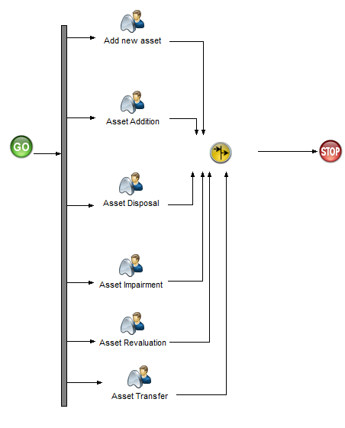

77. Process: Asset Maintenance

Process Content

* Add new asset

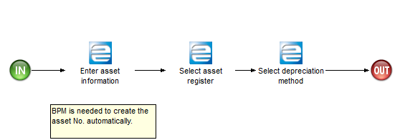

78. Process: Asset Maintenance, Stage: Add new asset

**GAPs/ Configuration changes Identified:**

|  |  |  |  |
| --- | --- | --- | --- |
| Definition | Type |  | Comments |
| Asset No. need to be automated | BPM |  | Create BPM to create asset No. automatically. |

* Asset Addition

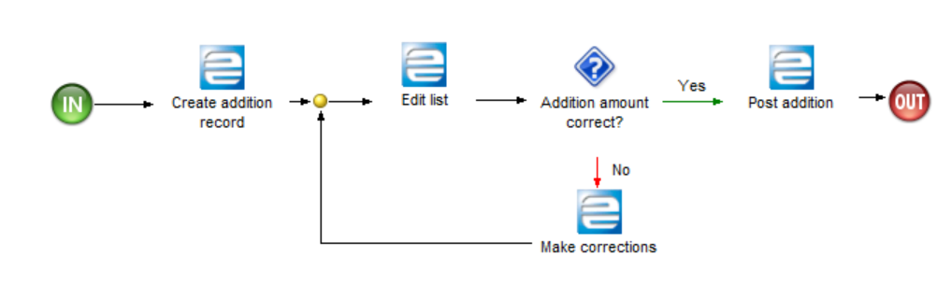

79. Process: Asset Maintenance, Stage: Asset Addition

* Asset Disposal

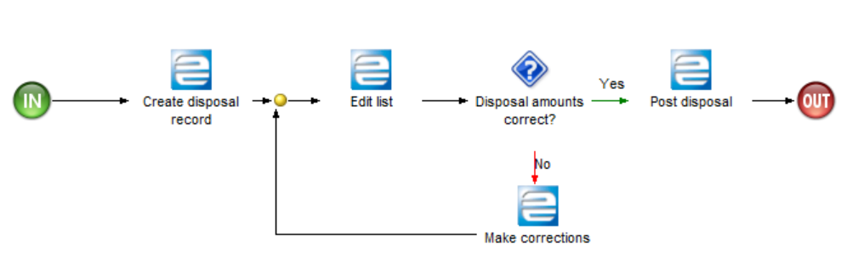

80. Process: Asset Maintenance, Stage: Asset Disposal

* Asset Impairment

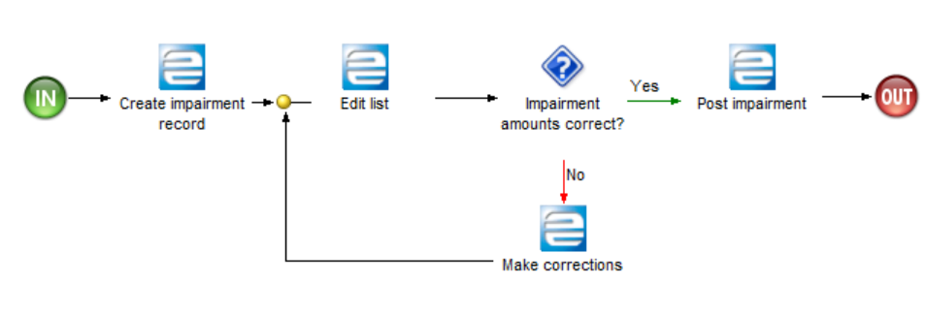

81. Process: Asset Maintenance, Stage: Asset Impairment

* Asset Revaluation

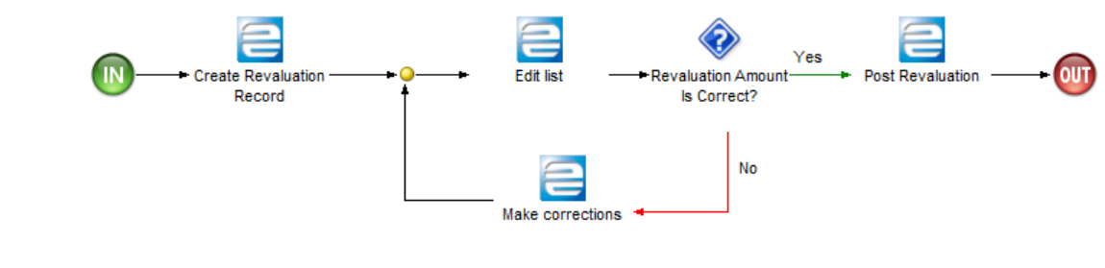

82. Process: Asset Maintenance, Stage: Asset Revaluation

* Asset Transfer

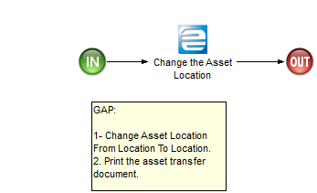

83. Process: Asset Maintenance, Stage: Asset Transfer

**GAPs/ Configuration changes Identified:**

|  |  |  |  |
| --- | --- | --- | --- |
| Definition | Type |  | Comments |
| Transfer asset between locations. | Enhancement |  | Transfer asset between locations and tracking this move by having some report. |

AM Period End

|  |
| --- |
| User Notes |
| Process definition:  This process starts with process of depreciating the asset and period end.  This workflow starts from calculate asset depreciation, review and post and close asset period. |

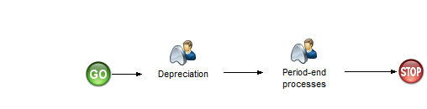

84. Process: AM Period End

Process Content

* Depreciation

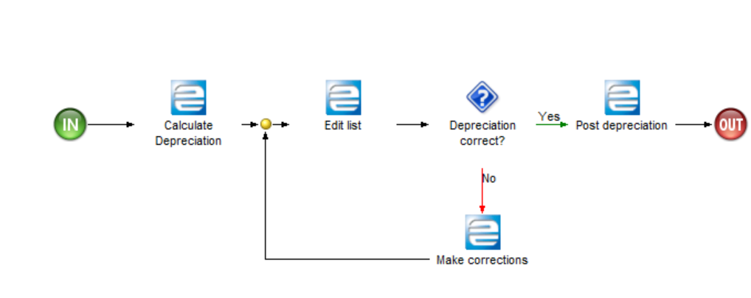

85. Process: AM Period End, Stage: Depreciation

* Period-end processes

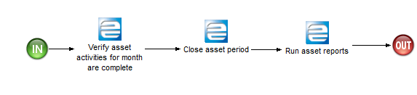

86. Process: AM Period End, Stage: Period-end processes

**GAPs/ Configuration changes Identified:**

|  |  |  |  |
| --- | --- | --- | --- |
| Definition | Type |  | Comments |
| N/A | N/A |  | N/A |

Projects

The following item(s) are in this Group:

* Projects

Projects

|  |
| --- |
| User Notes |
| Process definition:  This group contains the process related to project in Epicor10 database.  MSD will use the project for capitalizing the asset the tracking the work in progress. |

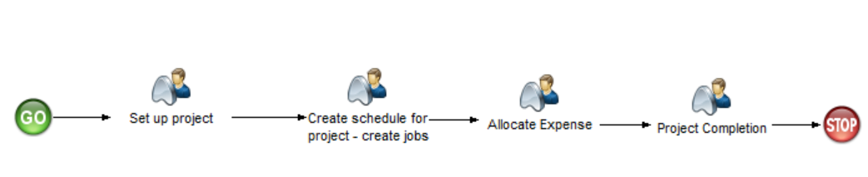

87. Process: Projects

Process Content

* Set up project

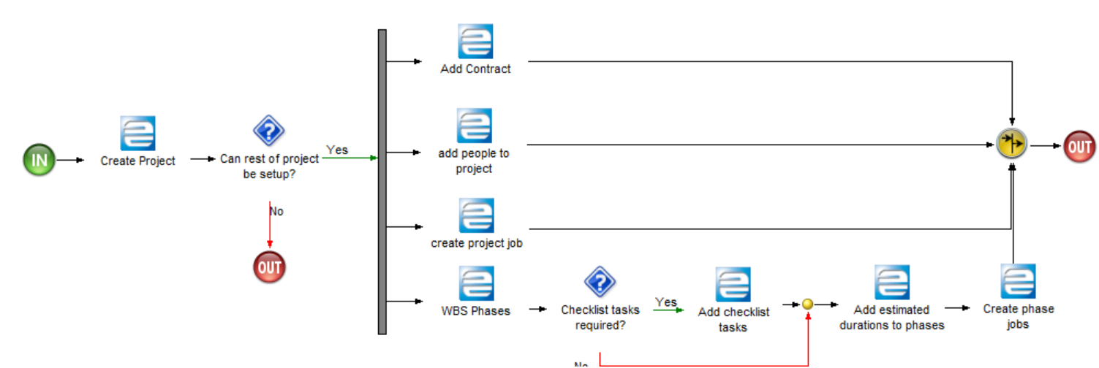

88. Process: Projects, Stage: Set up project

* Create schedule for project - create jobs

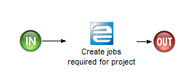

89. Process: Projects, Stage: Create schedule for project - create jobs

* Project Completion

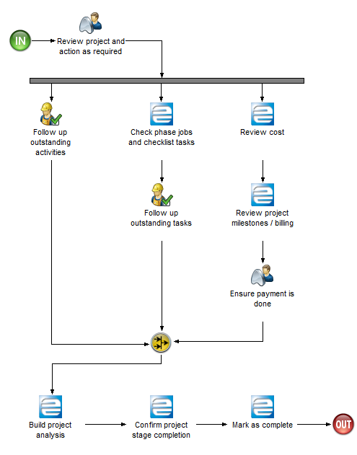

90. Process: Projects, Stage: Project Completion

* Allocate Expense

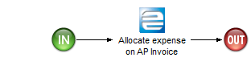

91. Process: Projects, Stage: Allocate Expense

**GAPs/ Configuration changes Identified:**

|  |  |  |  |
| --- | --- | --- | --- |
| Definition | Type |  | Comments |
| N/A | N/A |  | N/A |

Integration

* There is no integration with any third party software.

General Notes

* MSD has only one legal entity(Company) with 13 plants(sites).
* iScala payroll is switched off and only the payroll module inside Epicor is currently used. The whole document did not talk anything about improving the payroll module of Epicor 9. Please consider this.
* There is no integration between HCM and payroll module and we shouldn’t consider this as part of the new Epicor10 implementation.
* Ability to track expenses by say motor vehicle/generator/other equipment
* Discussed about ability to handle staff imprest request and retirement to enable control of budget. This has not been shown.